WESTLYNN ENTERPRISES LLC.
MATTRESS RECYCLING
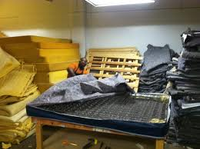
$5.00 CHARGE FOR ALL MATTRESSES PICK-UPS IS FREE!
OUR GOAL IS TO KEEP OUR LANDFILLS AS CLEAN AS POSSIBLE!
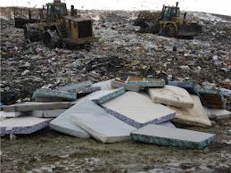
CALL 419-688-1022
WESTLYNNENTERPRISESLLC.YOLASITE.COM

